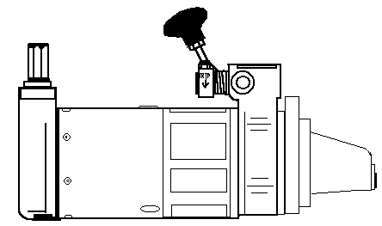
WORKWELL ENGINEERING INDIA
268/2/C G.T. Road, Liluah, Howrah-711204, W.B., India.
Web : workwellengineering.com

e-mail : contact@workwellengineering.com

prashan_agarwal@hotmail.com

Ph No : +91 9830040284, +91 9874054984
DATAFORM
In order to establish the correct type of starter for your engine application please fill in as much of the form below as possible and return it by e-mail. Please also send any additional information that you may feel important (e.g. engine drawings, current starter specifications). The more information we have, the easier it will be to find the right solution for you.
Your name
Company name
Address
Telephone
e-mail
Engine Details
Make & Type
Year of Manufacture
Application
No. of cylinders
Capacity (Lt)
Fuel injection system | Direct
Fuel injection system | Indirect
Fuel injection system | In-line
Fuel injection system | Rotary
Is excess fuel available? | Yes / No
Make & type of fuel injection pump
Present starting system | Electric
Present starting system | Air
Present starting system | Hydraulic
Present starting system | Hand-cranking
Make of current starter
Type number of starter
Are starting aids permissible for low temperature? | Yes / No

Equipment Details
Generator Set: |  | Compressor: |  | Welding Set:
Pumps: |  | Boats |  | Tractors:
Other:
Engine coupling:
Directly coupled |  | Clutch coupled |  | Fluid flywheel drive
Is the Strong Starter required as:
Main starter |  | Secondary starter |  | Emergency starter
Will the following need modifying to be accessible:
Winding handle |  | Trip lever

How many starters will be required

Please fill in the following information based on the above diagrams:
Winding handle angle, A
Mounting hole diameter, Y
Centre distance, W
P.C.R. fixing holes, X
Angle (left or right), B or C
Mounting hole angle, D
Bolt / stud diameter, Z
Starter mounting face to flywheel face, U

Clearance between mounting flange and engine obstructions, V
Direction of rotation of engine facing flywheel | Clockwise or Counter Clockwise
Tooth form of flywheel (module / fellow stub)
Number of teeth
P.C.D. (flywheel)
Tooth form of pinion
Number of teeth (pinion)
P.C.D. (pinion)
Flange type required
SAE 1 |  | SAE 2&3 |  | SAE 4
Available space for starter- mounting flange to nearest obstruction

